**Kalinga Institute of Industrial Technology**

**CN LAB-3**

NAME: Ankit Raj

ROLL NO: 1906534

1. **Write a client server program where the client sends and the server accepts it and prints it till exit is not sent.**

Server.c

**#include <arpa/inet.h>**

**#include <netinet/in.h>**

**#include <stdio.h>**

**#include <string.h>**

**#include <sys/socket.h>**

**#include <sys/stat.h>**

**#include<unistd.h>**

**#include <sys/types.h>**

**int main()**

**{**

**struct sockaddr_in client, server;**

**int s, n, sock,flag_534=0;**

**char b1_534[20];**

**s = socket(AF_INET, SOCK_STREAM, 0);**

**server.sin_family = AF_INET;**

**server.sin_port = 2000;**

**server.sin_addr.s_addr = inet_addr("127.0.0.1");**

**bind(s, (struct sockaddr*)&server, sizeof server);**

**listen(s, 1);**

**n = sizeof client;**

**sock = accept(s, (struct sockaddr*)&client, &n);**

**while(flag_534==0)**

**{**

**recv(sock, b1_534, sizeof(b1_534), 0);**

**if(strcmp(b1_534,"exit")==0)**

**flag_534=1;**

**printf("\nThe string received is:%s\n", b1_534);**

**}**

**close(sock);**

**close(s);**

**}**

Client.c

**#include <arpa/inet.h>**

**#include <netinet/in.h>**

**#include <stdio.h>**

**#include <string.h>**

**#include <sys/socket.h>**

**#include<unistd.h>**

**#include <sys/stat.h>**

**#include <sys/types.h>**

**int main()**

**{**

**struct sockaddr_in client;**

**int s, flag_534;**

**char buffer_534[20];**

**s = socket(AF_INET, SOCK_STREAM, 0);**

**client.sin_family = AF_INET;**

**client.sin_port = 2000;**

**client.sin_addr.s_addr = inet_addr("127.0.0.1");**

**connect(s, (struct sockaddr*)&client, sizeof client);**

**for (;;) {**

**printf("\nEnter a string: ");**

**scanf("%s", buffer_534);**

**send(s, buffer_534, sizeof(buffer_534), 0);**

**if(strcmp(buffer_534,"exit")==0)**

**break;**

**}**

**close(s);**

**}**

**OUTPUT:**

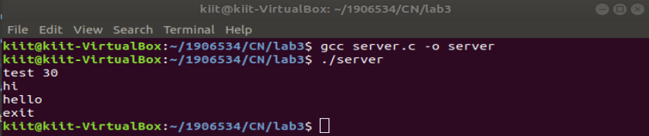

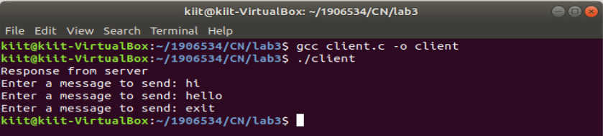

1. **Write a client server program to reverse a number which client sends to the server**

Server.c

**#include <arpa/inet.h>**

**#include <netinet/in.h>**

**#include<unistd.h>**

**#include <stdio.h>**

**#include <string.h>**

**#include<stdlib.h>**

**#include <sys/socket.h>**

**#include <sys/stat.h>**

**#include <sys/types.h>**

**int main()**

**{**

**struct sockaddr_in client, server;**

**int s, n, sock;**

**char a_534[100],*b;**

**s = socket(AF_INET, SOCK_STREAM, 0);**

**server.sin_family = AF_INET;**

**server.sin_port = 2000;**

**server.sin_addr.s_addr = inet_addr("127.0.0.1");**

**bind(s, (struct sockaddr*)&server, sizeof server);**

**listen(s, 1);**

**n = sizeof client;**

**sock = accept(s, (struct sockaddr*)&client, &n);**

**recv(s, a_534, sizeof(a_534), 0);**

**send(s,a_534,sizeof(a_534),0);**

**close(sock);**

**close(s);**

**}**

Client.c

**#include <arpa/inet.h>**

**#include <netinet/in.h>**

**#include <stdio.h>**

**#include <string.h>**

**#include <sys/socket.h>**

**#include<stdlib.h>**

**#include<unistd.h>**

**#include <sys/stat.h>**

**#include <sys/types.h>**

**int main()**

**{**

**struct sockaddr_in client;**

**int l_534,s_534, flag_534;**

**char buffer_534[20];**

**s_534 = socket(AF_INET, SOCK_STREAM, 0);**

**client.sin_family = AF_INET;client.sin_port = 2000;**

**client.sin_addr.s_addr = inet_addr("127.0.0.1");**

**connect(s_534, (struct sockaddr*)&client, sizeof client);**

**scanf("%s_534",buffer_534);**

**send(s_534,buffer_534,sizeof(buffer_534),0);**

**recv(s_534,buffer_534,sizeof(buffer_534),0);**

**l_534=strlen(buffer_534);**

**for(int i=l_534-1;i>=0;i--)**

**printf("%c",buffer_534[i]);**

**close(s_534);**

**}**

**OUTPUT:**

